[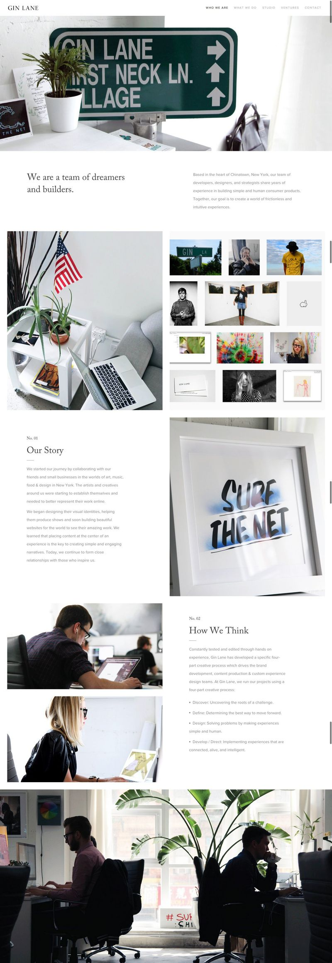](http://ginlane.com/who-we-are)

[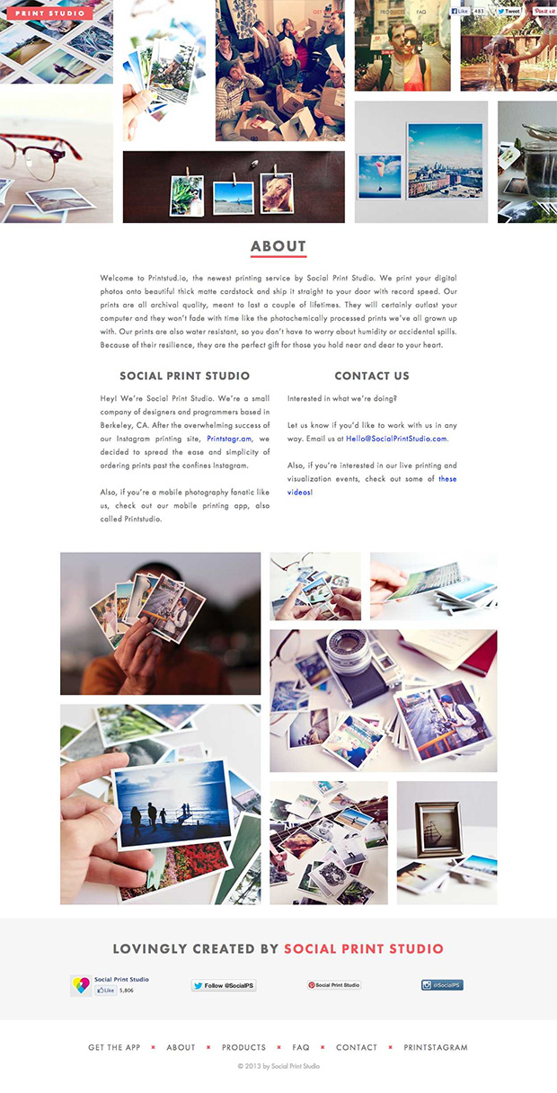](http://printstud.io/about)